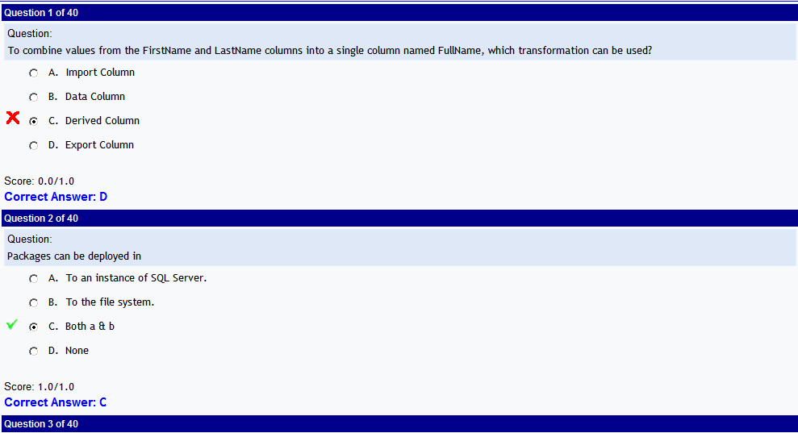

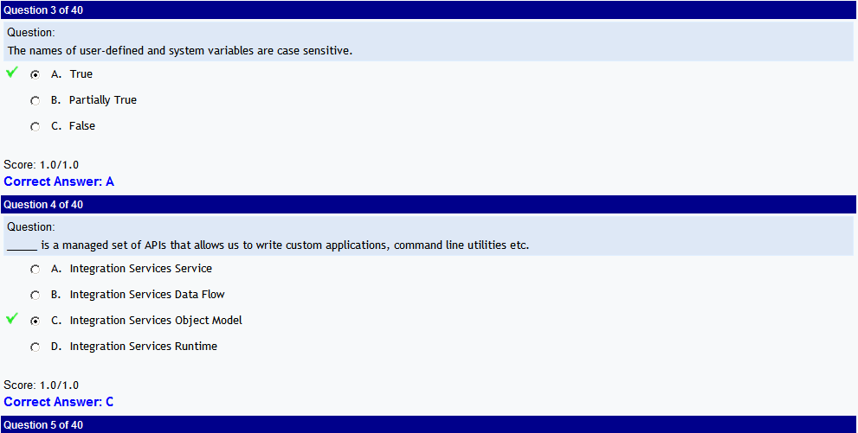

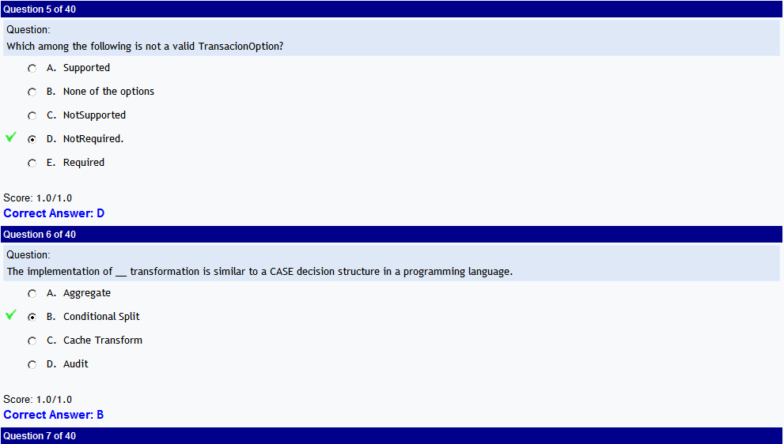

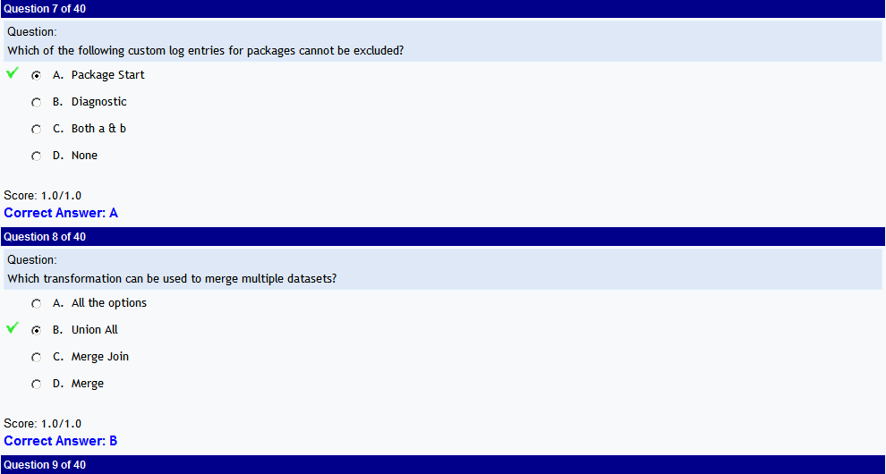

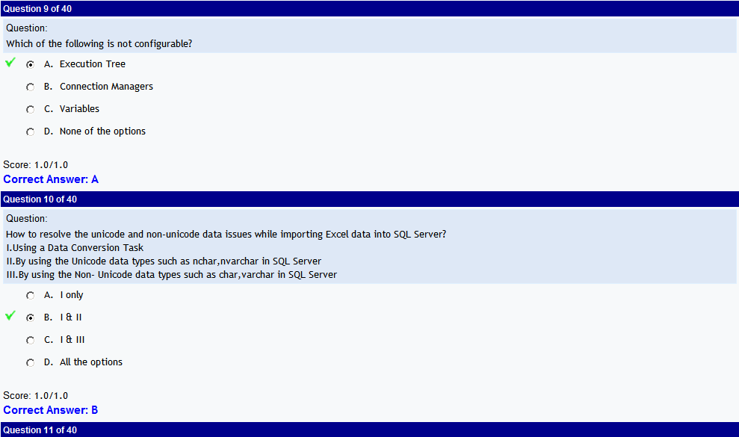

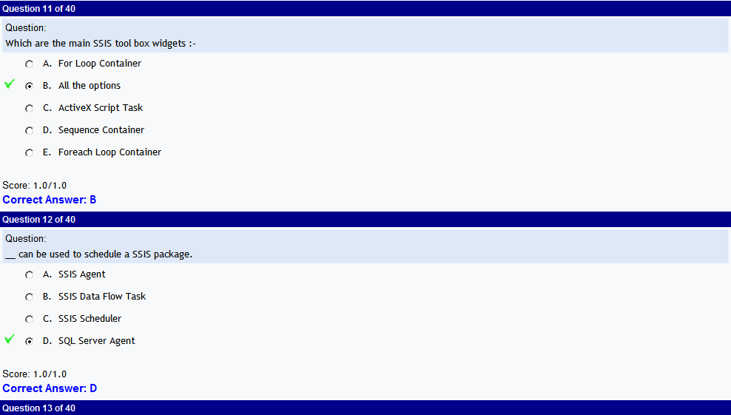

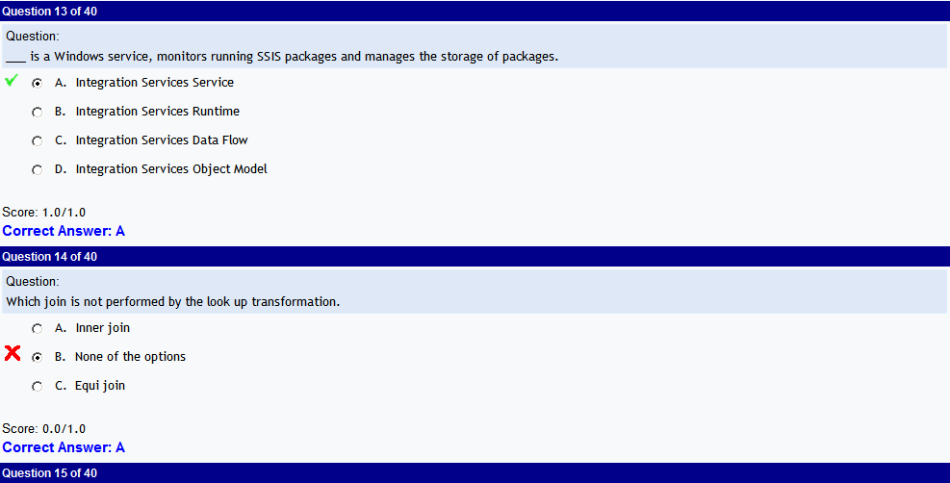

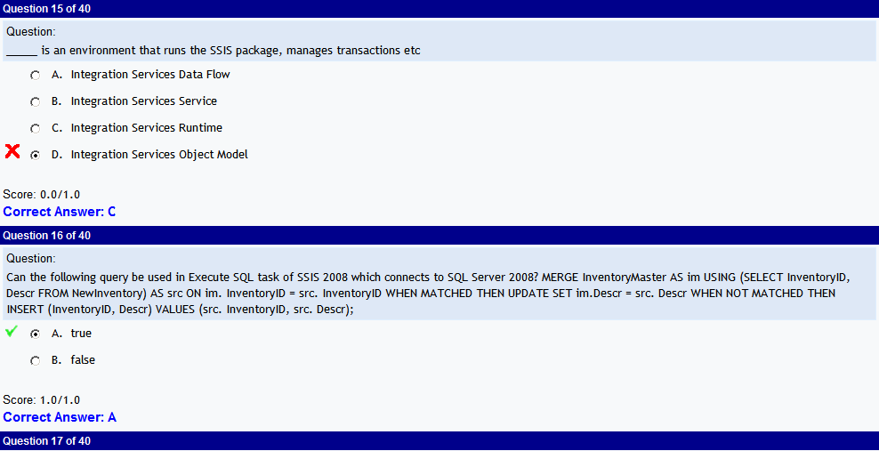

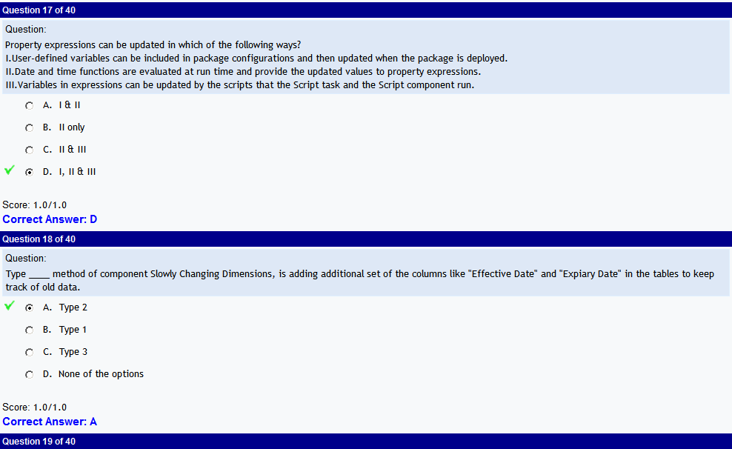

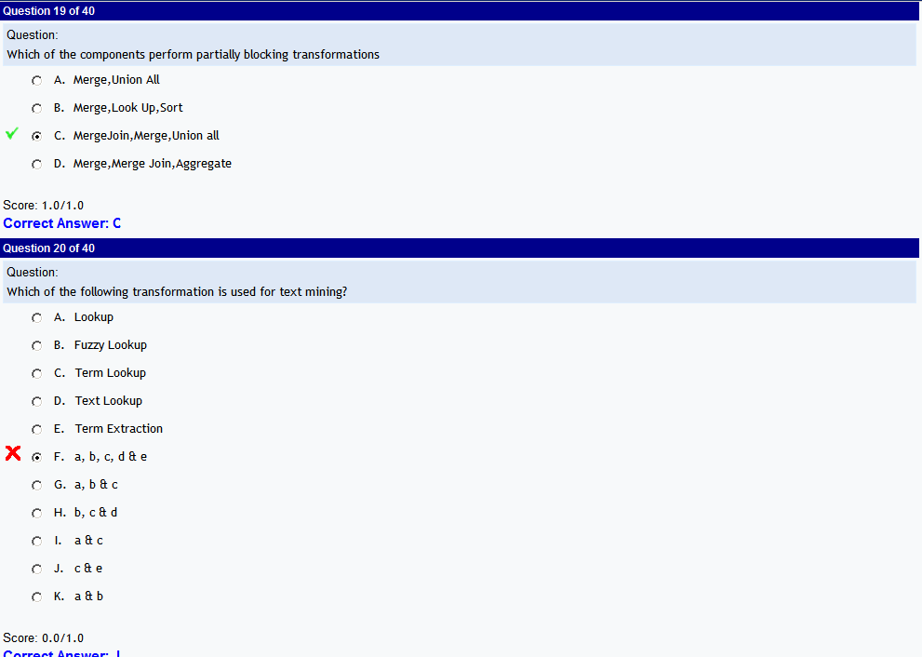

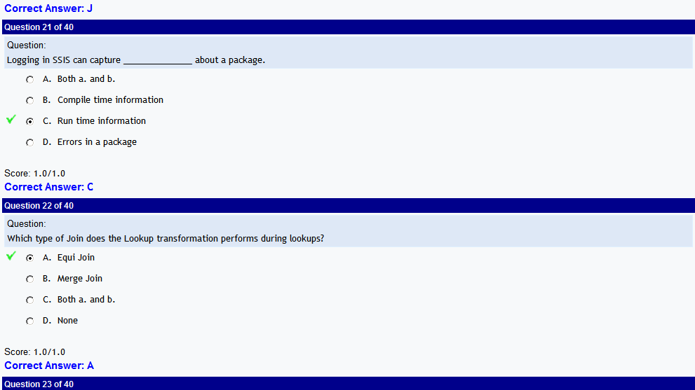

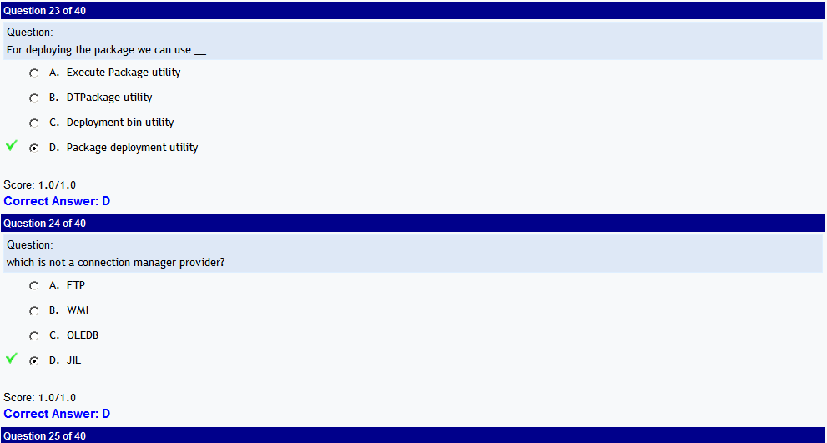

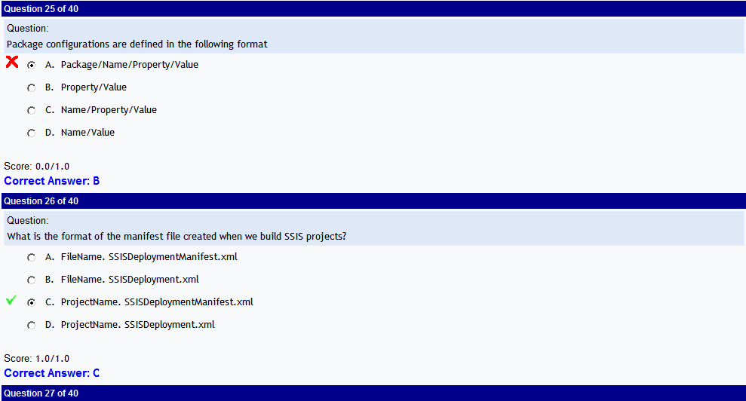

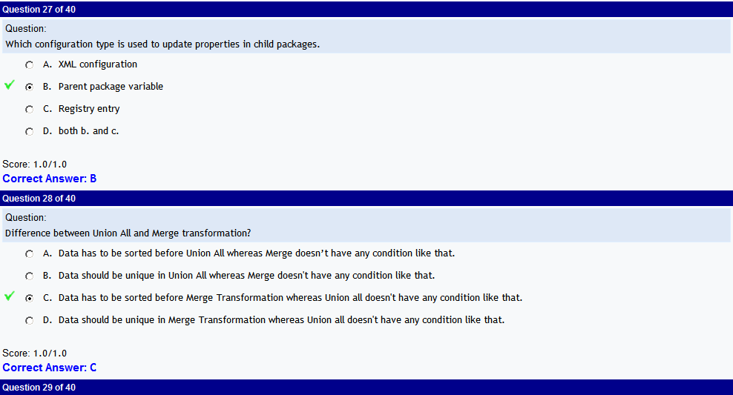

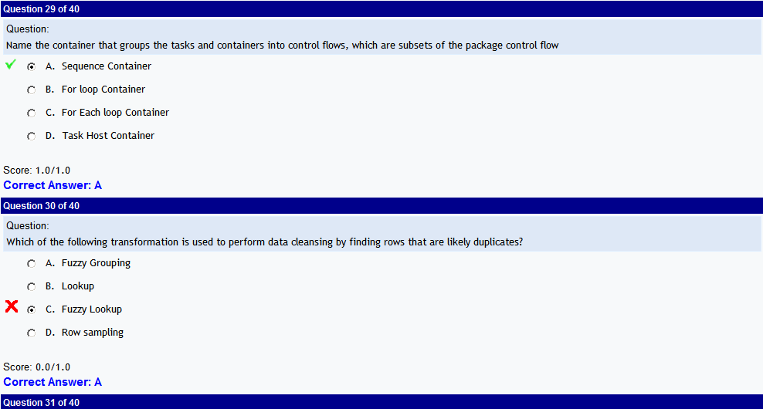

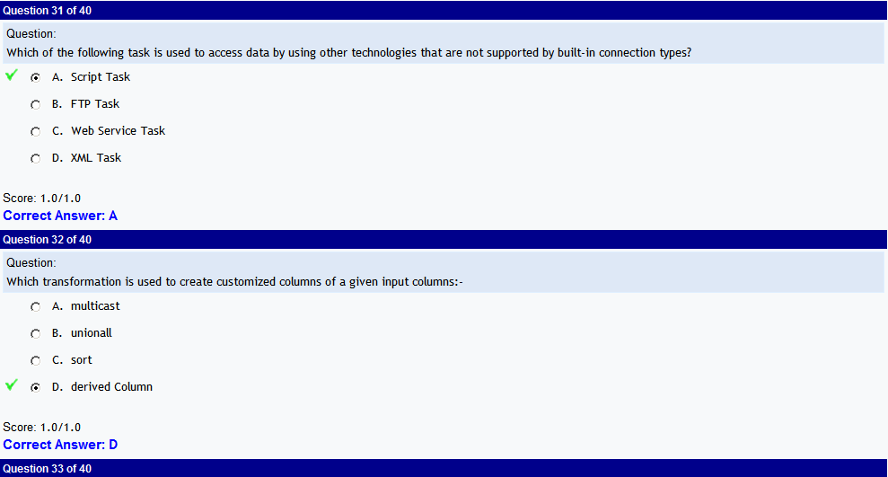

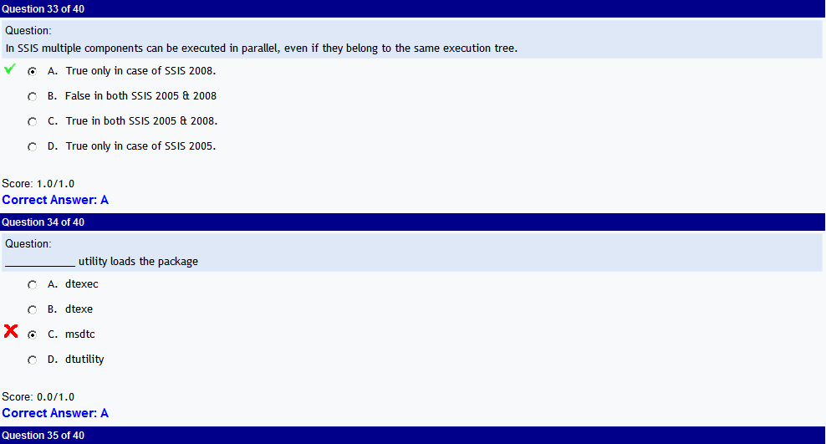

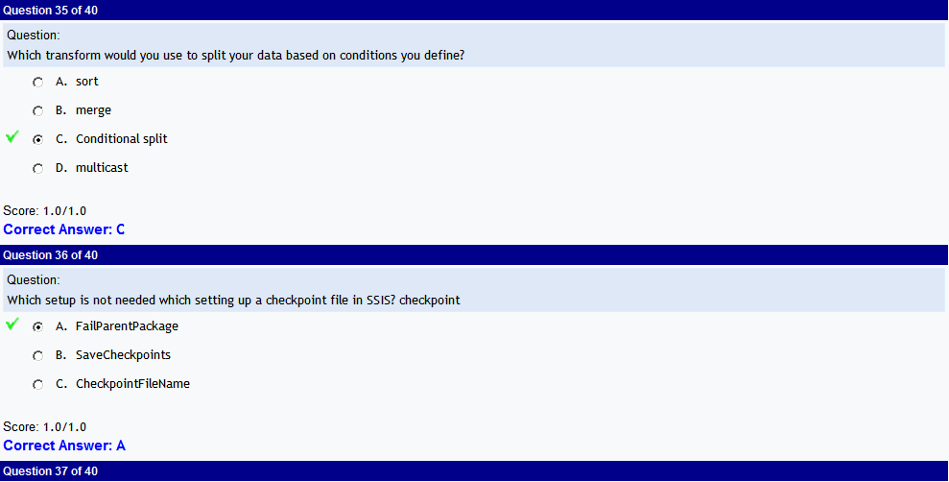

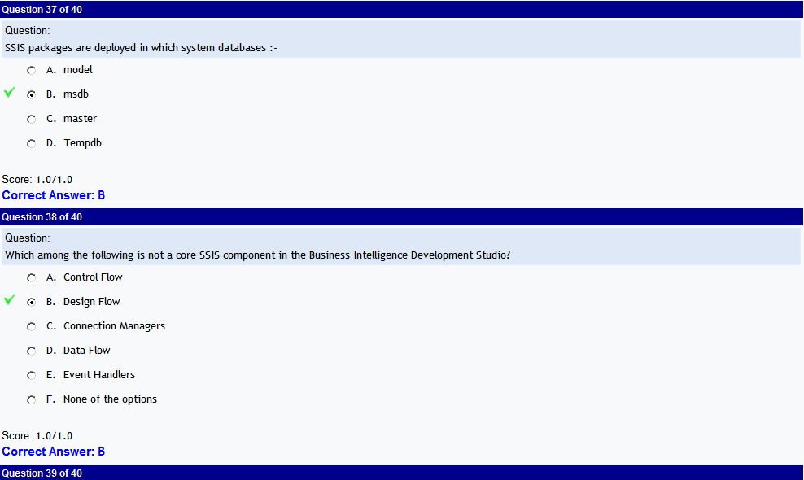

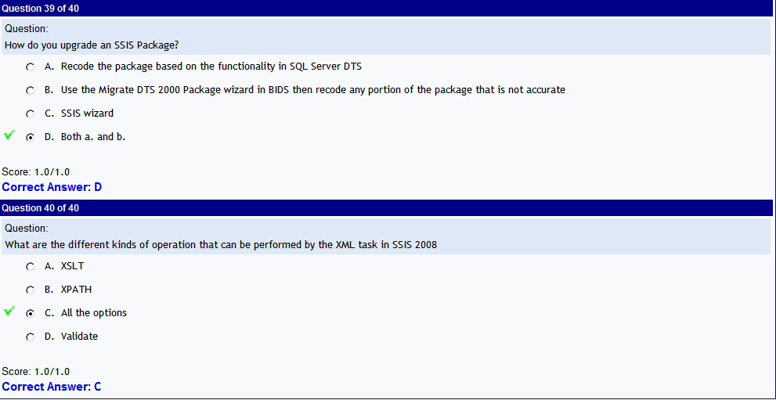

|  | C:\DOCUME~1\srinivas\LOCALS~1\Temp\msohtmlclip1\01\clip_image124.png |
| --- | --- |
|  | C:\DOCUME~1\srinivas\LOCALS~1\Temp\msohtmlclip1\01\clip_image124.png |
|  | C:\DOCUME~1\srinivas\LOCALS~1\Temp\msohtmlclip1\01\clip_image125.png |
|  | C:\DOCUME~1\srinivas\LOCALS~1\Temp\msohtmlclip1\01\clip_image125.png |
|  | C:\DOCUME~1\srinivas\LOCALS~1\Temp\msohtmlclip1\01\clip_image126.png |
|  | C:\DOCUME~1\srinivas\LOCALS~1\Temp\msohtmlclip1\01\clip_image126.png |
|  | C:\DOCUME~1\srinivas\LOCALS~1\Temp\msohtmlclip1\01\clip_image127.png |
|  | C:\DOCUME~1\srinivas\LOCALS~1\Temp\msohtmlclip1\01\clip_image127.png |
|  | C:\DOCUME~1\srinivas\LOCALS~1\Temp\msohtmlclip1\01\clip_image128.png |
|  | C:\DOCUME~1\srinivas\LOCALS~1\Temp\msohtmlclip1\01\clip_image128.png |
|  | C:\DOCUME~1\srinivas\LOCALS~1\Temp\msohtmlclip1\01\clip_image129.png |
|  | C:\DOCUME~1\srinivas\LOCALS~1\Temp\msohtmlclip1\01\clip_image129.png |
|  | C:\DOCUME~1\srinivas\LOCALS~1\Temp\msohtmlclip1\01\clip_image130.png |
|  | C:\DOCUME~1\srinivas\LOCALS~1\Temp\msohtmlclip1\01\clip_image130.png |
|  | C:\DOCUME~1\srinivas\LOCALS~1\Temp\msohtmlclip1\01\clip_image131.png |
|  | C:\DOCUME~1\srinivas\LOCALS~1\Temp\msohtmlclip1\01\clip_image131.png |
|  | C:\DOCUME~1\srinivas\LOCALS~1\Temp\msohtmlclip1\01\clip_image132.png |
|  | C:\DOCUME~1\srinivas\LOCALS~1\Temp\msohtmlclip1\01\clip_image132.png |
|  | C:\DOCUME~1\srinivas\LOCALS~1\Temp\msohtmlclip1\01\clip_image133.png |
|  |  |
|  | C:\DOCUME~1\srinivas\LOCALS~1\Temp\msohtmlclip1\01\clip_image134.png |
|  | C:\DOCUME~1\srinivas\LOCALS~1\Temp\msohtmlclip1\01\clip_image134.png |
|  | C:\DOCUME~1\srinivas\LOCALS~1\Temp\msohtmlclip1\01\clip_image135.png |
|  | C:\DOCUME~1\srinivas\LOCALS~1\Temp\msohtmlclip1\01\clip_image135.png |
|  | C:\DOCUME~1\srinivas\LOCALS~1\Temp\msohtmlclip1\01\clip_image136.png |
|  | C:\DOCUME~1\srinivas\LOCALS~1\Temp\msohtmlclip1\01\clip_image136.png |
|  | C:\DOCUME~1\srinivas\LOCALS~1\Temp\msohtmlclip1\01\clip_image137.png |
|  | C:\DOCUME~1\srinivas\LOCALS~1\Temp\msohtmlclip1\01\clip_image137.png |
|  | C:\DOCUME~1\srinivas\LOCALS~1\Temp\msohtmlclip1\01\clip_image138.png |
|  | C:\DOCUME~1\srinivas\LOCALS~1\Temp\msohtmlclip1\01\clip_image138.png |
|  | C:\DOCUME~1\srinivas\LOCALS~1\Temp\msohtmlclip1\01\clip_image139.png |
|  | C:\DOCUME~1\srinivas\LOCALS~1\Temp\msohtmlclip1\01\clip_image139.png |
|  | C:\DOCUME~1\srinivas\LOCALS~1\Temp\msohtmlclip1\01\clip_image140.png |
|  | C:\DOCUME~1\srinivas\LOCALS~1\Temp\msohtmlclip1\01\clip_image140.png |
|  | C:\DOCUME~1\srinivas\LOCALS~1\Temp\msohtmlclip1\01\clip_image141.png |
|  | C:\DOCUME~1\srinivas\LOCALS~1\Temp\msohtmlclip1\01\clip_image141.png |
|  | C:\DOCUME~1\srinivas\LOCALS~1\Temp\msohtmlclip1\01\clip_image142.png |
|  | C:\DOCUME~1\srinivas\LOCALS~1\Temp\msohtmlclip1\01\clip_image142.png |
|  | C:\DOCUME~1\srinivas\LOCALS~1\Temp\msohtmlclip1\01\clip_image143.png |
|  | C:\DOCUME~1\srinivas\LOCALS~1\Temp\msohtmlclip1\01\clip_image143.png |
|  | C:\DOCUME~1\srinivas\LOCALS~1\Temp\msohtmlclip1\01\clip_image144.png |